**ONTARIO ECOLOGY, ETHOLOGY, AND EVOLUTION COLLOQUIUM**

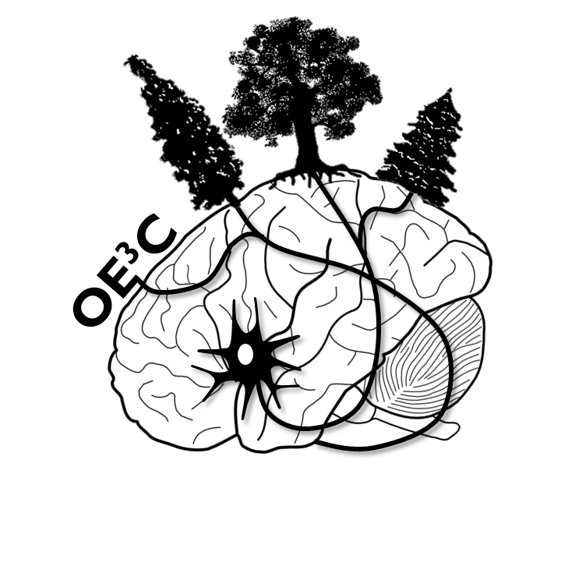

**MAY 8-10, 2014**



**PROGRAM CONTENT**

Introduction and Welcome ……………………………………………………. 3

2014 Organizing Committee ………………………………………………….. 4

Important Information ………………………………………………………….. 5

Campus Map …………………………………………………………………………. 7

Plenary Speakers ………………………………………………………………….. 9

Conference Schedule …………………………………………………………….. 10

Talk Sessions ………………………………………………………………... 12

Posters …………………………………………………………………………. 17

Acknowledgements ………………………………………………………………. 19

**INTRODUCTION AND WELCOME**

Welcome to the 44th Ontario Ecology, Ethology, and Evolution Colloquium!

For decades, OE3C has brought together top researchers across Ontario to share findings in an intimate academic environment. Originally known as the Ontario Ecology and Ethology Colloquium, the recent addition of the third E – Evolution – significantly broadened the scope of this conference. This year, the Ontario Colloquium, with all of its three Es, is hosted by graduate students of the University of Guelph’s Integrative Biology, Animal and Poultry Science, and Psychology departments.

We are happy to welcome over 120 top researchers to share their exciting findings. Presentation topics are highly diverse, ranging from animal welfare, climate change, and conservation biology, to evolutionary psychology and social behaviour. We are also proud to have four plenary speakers present the most recent and intriguing findings within the fields of ecology, ethology, and evolution.

OE3C is a great way for young researchers to receive constructive feedback about their research, and for faculty to recruit, and interact with, top prospective students. Like past OE3Cs, this conference was entirely organized by a subset of dedicated graduate students. Together, we strive to make this conference a friendly, collaborative, fun, and positive academic experience for all.

Please enjoy your stay at Guelph and welcome to OE3C 2014!

Sara Kafashan

OE3C 2014 Organizing Committee Member

**2014 ORGANIZING COMMITTEE**

OE3C 2014 would not be possible without the hard work and dedication of the following individuals:

Jamie Ahloy Dallaire

Kate Eisen

Kelsy Ervin

Sara Kafashan

Tony Kess

Heather Kinkaid

Richard Matta

Zachary Ramsay

**IMPORTANT INFORMATION**

**Registration**

On Thursday, registration will be open from 5:30pm-7 pm in the Science Complex Atrium. Finger foods and drinks will be served.

On Friday and Saturday, registration will be open from 7:30-8:30 am in the Thornbrough Building.

Registration for OE3C 2014 includes a conference package, two dinnertime receptions, other meals, coffee breaks, and two drink tickets.

**Oral Presentations**

Please report to your scheduled room in the Thornbrough or Richards Building 15 minutes *before* your session begins so a moderator can help you load your presentation onto the audio-visual equipment.

All presentations will be loaded onto the room computer prior to the beginning of the session. To avoid compatibility issues, presentations should be saved as a **powerpoint file (.ppt)**.

Oral presentations are 15 minutes maximum (12 minutes, with 3 minutes for questions). Moderators in your session will signal to you at 10 minutes, and will ask you to wrap up at 14 minutes.

*Please be prompt and respectful to help us stay on schedule!*

**Poster Presentations**

Poster boards will be set up in the atrium of the Science Complex. Please feel free to hang your poster anytime after 1pm with the materials provided.

Please ensure your poster is no more than 4ft by 3ft.

Finger foods and drinks will be served during the poster session.

Be sure to remove your poster after the session is over. Unclaimed posters will be discarded by the end of the conference.

**T-Shirts**

Pre-ordered t-shirts will be handed out with your registration package.

Extra t-shirts will be available for purchase ($15 each) at the registration desk.

**Parking**

Parking is available on campus (see parking availability on the campus map).

**Meals**

The opening reception will be held from 5:30-7:00 pm on Thursday evening (during registration), in the Science Complex Atrium (see campus map). Finger foods and drinks will be served.

Breakfast will be served from 7:30-8:30 am on Friday and Saturday (during morning registration), in the Thornbrough Building (see campus map).

Lunches will be held in the University Centre on Friday and in the Thornbrough Concourse on Saturday (see campus map).

The poster session reception will be held from 5:00-7:00 pm on Friday evening, in the Science Complex Atrium (see campus map). Finger foods and drinks will be served.

**Accommodation**

On-campus housing will be in the East side residence buildings (see campus map). Off-campus housing will be at the Delta Hotel (see campus map).

Check in is 3:00 pm and check out is 11:00 am.

**CAMPUS MAP**

Lot P14:

Friday

(with pass)

Lot P15:

Friday

(with pass)

**Thornbrough**

**building**

**richards**

**building**

**Science**

**Complex**

**From Hanlon Pkwy (Hwy 6 N)**

**North from 401, exit 295**

**South from Hwy 7**

**From Hamilton (Hwy 6 S)**

**From 401, exit 299**

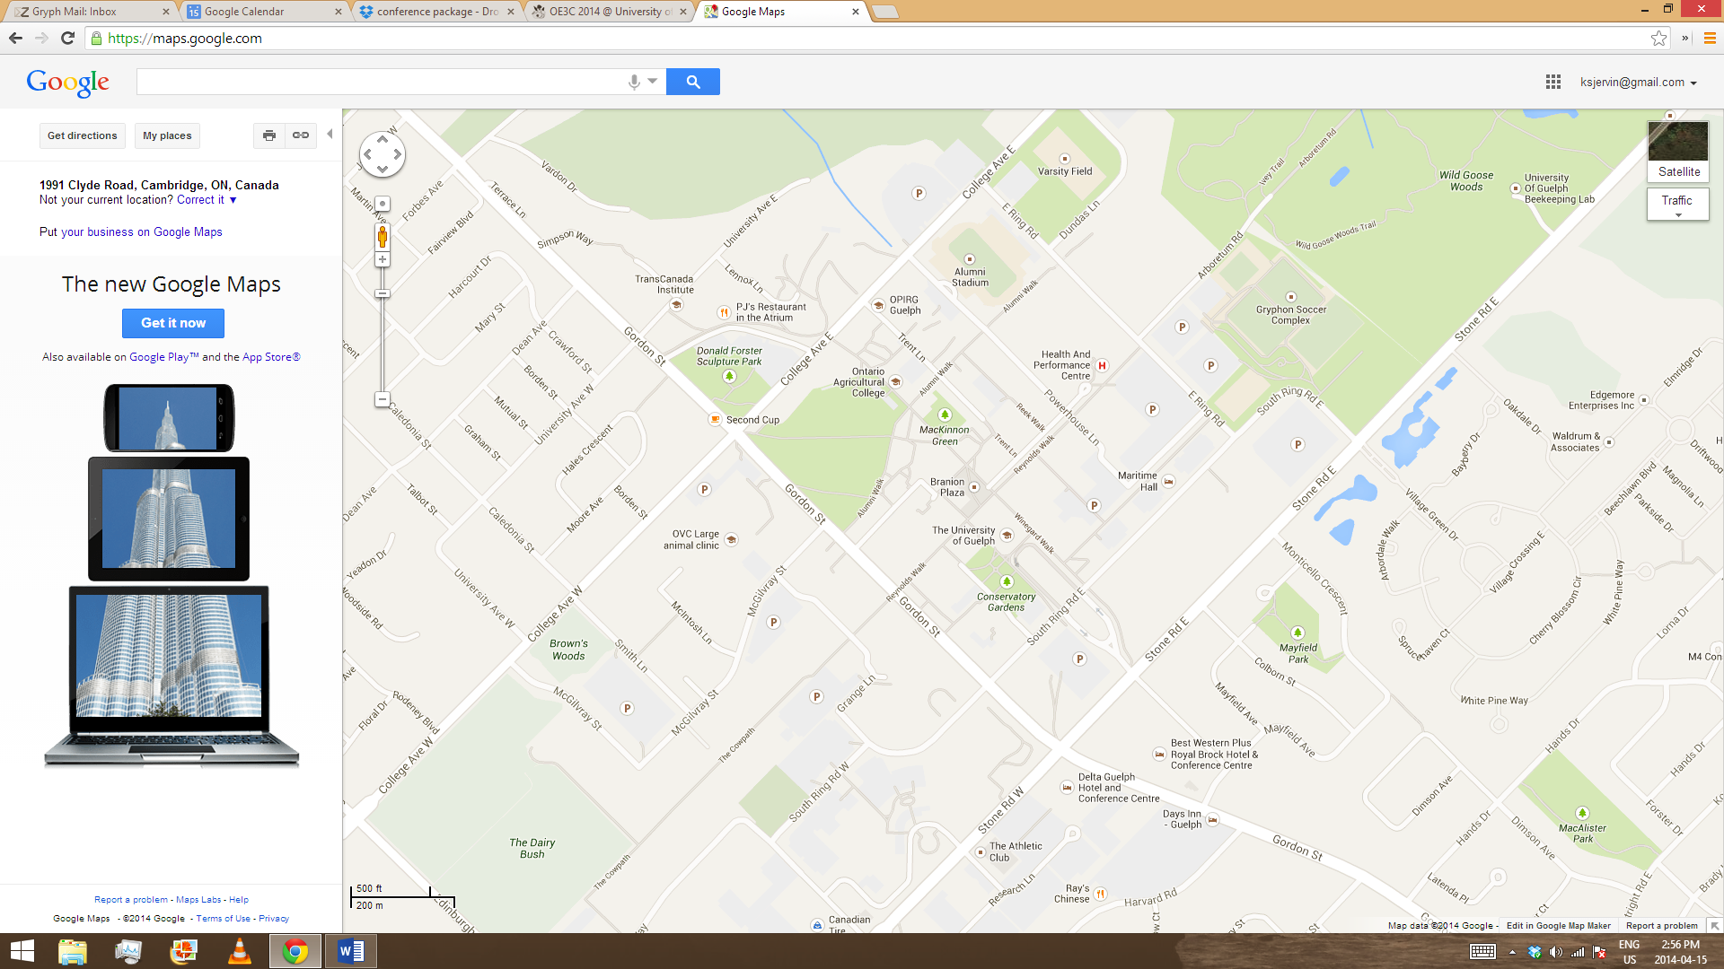

Lot P31: Thursday evening, Saturday

**CAMPUS MAP**

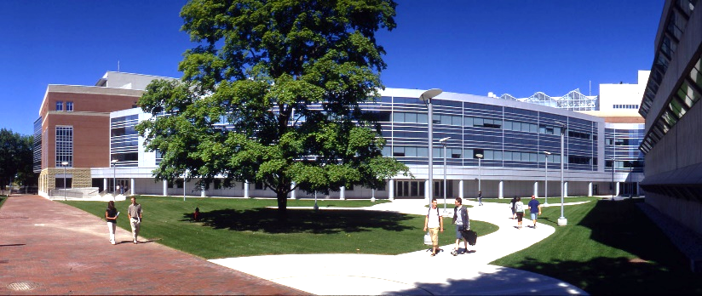**Venues:**

Science Complex Atrium

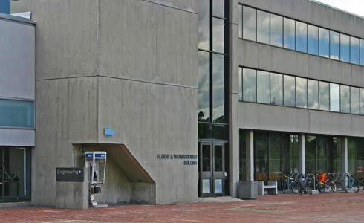Thornbrough Building

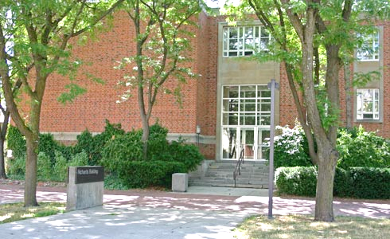Richards Building

**PLENARY SPEAKERS**

**Dr. Hafiz Maherali**

Department of Integrative Biology, University of Guelph

**What maintains a 400 million year old trophic interaction? Exploring evolutionary causes and ecological consequences in the mycorrhizal symbiosis**

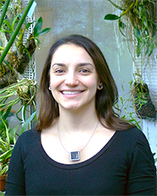**Dr. Nicole Mideo**

Department of Ecology and Evolutionary Biology, University of Toronto

**Explaining the complex lives of malaria parasites**

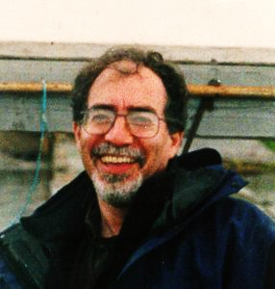**Dr. Bennett Galef**

Department of Psychology, Neuroscience, & Behaviour, McMaster University

**Social influences on the food choices of Norway rats: Behaviour, Neuroscience, and Molecular Biology**

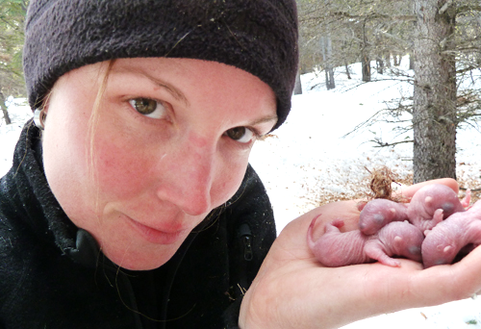**Dr. Amy Newman**

Department of Integrative Biology, University of Guelph

**The influence of the early-life environment on adult stress physiology and fitness in the wild**

**CONFERENCE SCHEDULE**

|  |  |
| --- | --- |
| **Thursday, May 8**  *Science Complex Atrium* | |
| 5:30-7:00 | Opening reception and registration |
| 7:00-8:00 | **Plenary speaker: Hafiz Maherali**  What maintains a 400 million year old trophic interaction? Exploring evolutionary causes and ecological consequences in the mycorrhizal symbiosis |

|  |  |
| --- | --- |
| **Friday, May 9** | |
| 7:30-8:30 | Registration and Breakfast  *Thornbrough Concourse* |
| 8:30-9:30 | **Plenary speaker: Nicole Mideo**  Explaining the complex lives of malaria parasites  *Thornbrough 1200* |
| 9:30-10:00 | Coffee break |
| 10:00-12:15 | **Session 1A:** Evolutionary Ecology  *Thornbrough 1200* |
| **Session 1B:** Aquatic Ecology  *Richards 2520* |
| 12:15-1:15 | Lunch |
| 1:15-3:00 | **Session 2A:** Conservation Biology and Biodiversity  *Thornbrough 1200* |
| **Session 2B:** Avian Ecology and Behaviour  *Richards 2520* |
| 3:00-3:30 | Coffee break |
| 3:30-4:30 | **Plenary speaker: Bennett Galef**  Social influences on the food choices of Norway rats: Behaviour, Neuroscience, and Molecular Biology  *Thornbrough 1200* |
| 5:00-7:00 | **Poster Session**  *Science Complex Atrium* |

**CONFERENCE SCHEDULE**

|  |  |
| --- | --- |
| **Saturday, May 10** | |
| 7:30-8:30 | Registration and Breakfast  *Thornbrough Concourse* |
| 8:30-9:45 | **Session 3A:** Animal Welfare and Enrichment  *Thornbrough 1200* |
| **Session 3B:** Evolution of Behaviour  *Richards 2520* |
| 9:45-10:15 | Coffee break |
| 10:15-12:15 | **Session 4A:** Social Behaviour and Mate Selection  *Thornbrough 1200* |
| **Session 4B:** Climate Change and Invasion Biology  *Richards 2520* |
| 12:15-1:30 | Lunch |
| 1:30-3:45 | **Session 5A:** Community Ecology  *Thornbrough 1200* |
| **Session 5B:** Insect Ecology and Behaviour  *Richards 2520* |
| 3:45-4:15 | Coffee break |
| 4:15-5:15 | **Plenary speaker: Amy Newman**  The influence of the early-life environment on adult stress physiology and fitness in the wild  *Thornbrough 1200* |
| 5:15-5:30 | Student awards  *Thornbrough 1200* |

**TALK SESSIONS**

|  |  |
| --- | --- |
| **Session 1A: Evolutionary Ecology**  *Friday May 9, Thornbrough 1200* | |
| 10:00 | *A phylogenetic analysis of gynodioecy and its correlates in the flowering plants*  Kate Eisen, University of Guelph |
| 10:15 | *The mechanisms of frequency-dependent selection in gynodioecious* Lobelia siphilitica  L. Ruth Rivkin, University of Guelph |
| 10:30 | *An evaluation of DNA extraction methods for Western black widows across developmental stages: minimizing cost and effort*  Harrish Nithianandan, University of Toronto |
| 10:45 | *Testing for adaptive radiation and ecological constraint in a major lineage of rodents* (Hystricomorpha, Caviomorpha)  Nathan S. Upham, University of Chicago, Field Museum of Natural History |
| 11:00 | *A Rudiment's Tale: There and Back Again, The Resporption of the Juvenile Rudiment During Sea Urchin Larval Development*  Amardeep Singh, McMaster University |
| 11:15 | *Detecting genomic patterns of ecological adaptation in Galician* Littorina saxatilis *ecotypes through QTL mapping*  Joseph Anthony (Tony) Kess, University of Guelph |
| 11:30 | *Bee- to bird-pollination shifts in* Penstemon*: Effects of floral-lip removal and corolla constriction on bumble bee preference*  Jessica L. Zung, University of Toronto |
| 11:45 | *The genetic and environmental factors that influence unreduced gamete production*  Dylan Sora, University of Guelph |
| 12:00 | *Phylogenomics of African clawed frogs* (Xenopus)*: Implications for evolutionary dynamics of sex chromosomes*  Benjamin L. S. Furman, McMaster University |
| **Session 1B: Aquatic Ecology**  *Friday May 9, Richards 2520* | |
| 10:00 | *Molecular biogeography of the amphipod genus* Hyalella *in North America*  Matthew Hrycyshyn, University of Waterloo |
| 10:15 | *Are species larger at high latitudes? Testing latitude-body size relationships in ectotherms*  Jillian Moran, University of Toronto |
| 10:30 | *Ecomorphological diversification of neotropical cichlids*  Viviana Astudillo-Clavijo, University of Toronto |
| 10:45 | *The role of lure polymorphism in freshwater mussel reproduction: Are all lure types created equal?*  Colette S. Mesher, University of Guelph |
| 11:00 | *The selective feeding behaviours of adult and juvenile freshwater mussels under flowing conditions*  Rakesh Mistry, University of Guelph |
| 11:15 | *Ring the alarm: Behavioural manipulation of sea lamprey populations with damage-released alarm cues and predator cues*  István Imre, Algoma University |
| 11:30 | *The effects of suspended sediment on the suspension feeding of unionid mussels*  Shaylah Tuttle-Raycraft, University of Guelph |
| 11:45 | *Including ecology to particle capture mechanisms: The effects of oscillation on particle capture*  Dori Gao, University of Guelph |
| **Session 2A: Conservation Biology and Biodiversity**  *Friday May 9, Thornbrough 1200* | |
| 1:15 | *A window into our evolutionary past: Mazon Creek Lagerstatten siderite concretions*  Sarina Cotroneo, University of Toronto |
| 1:30 | *Small Ediacaran fronds of Mistaken Point*  Sara J. Mason, University of Guelph |
| 1:45 | *Elevation and the phylogenetic diversity of neotropical insects*  M. Alex Smith, University of Guelph |
| 2:00 | *Describing a group of Chilean bees,* Chilicola(Heteroediscelis)  Spencer K. Monckton, York University |
| 2:15 | *The use of Great Lakes islands by migrating bats*  Toby J. Thorne, University of Western Ontario |
| 2:30 | *The adaptive capacity of thermal tolerance: Reintroduction of Atlantic salmon into Lake Ontario*  Kayla J. Gradil, University of Western Ontario |
| 2:45 | *Improving the power and efficiency of biodiversity assessment through the use of DNA metasystematics and next-generation sequencing*  J. Gibson, University of Guelph |
| **Session 2B: Avian Ecology and Behaviour**  *Friday May 9, Richards 2520* | |
| 1:15 | *Do stressful conditions in early-life affect song preferences in adult female European starlings* (Sturnus vulgaris)*?*  Tara M. Farrell, University of Western Ontario |
| 1:30 | *The Effects of Corticosterone on Song Stereoypy in the Adult Zebra Finch*  Pavlina Faltynek, University of Western Ontario |
| 1:45 | *Sex differences in myelination of the song control system*  Adam Piraino, University of Western Ontario |
| 2:00 | *Is the HVC of black-capped chickadees (Poecile atricapillus) a vocal-control brain region rather than a song-control brain region?*  Shannon K. Mischler, University of Western Ontario |
| 2:15 | *Ready to fight: Reliable predictors of aggression in a joint-nesting nonpasserine bird*  Leanne A. Grieves, McMaster University |
| 2:30 | *Self-organization and individual attributes influence the formation of dominance hierarchies in a group-living bird*  Cody J. Dey, McMaster University |
| 2:45 | *Body size divergence is greater among sympatric species of birds in warm, but not cool, environments*  Emma Bothwell, University of Guelph |

|  |  |
| --- | --- |
| **Session 3A: Animal Welfare and Enrichment**  *Saturday May 10, Thornbrough 1200* | |
| 8:30 | *Using comparative methods to investigate welfare in captive* Psittaciformes*: Are there ecological determinants?*  Heather Y. McDonald Kinkaid, University of Guelph |
| 8:45 | *Does juvenile rough-and-tumble play enhance adult male sexual performance in farmed mink?*  Jamie Ahloy Dallaire, University of Guelph |
| 9:00 | *Having a ball: Mink given simple environmental enrichments are calmer and more fertile*  Georgia Mason, University of Guelph |
| 9:15 | *Wound healing in the wing membrane of the Cuban big fruit-eating bat* (Artibeus jamaicensis)  Tyler Pollock, McMaster University |
| 9:30 | *Validation of triaxial accelerometers to measure the lying behaviour of adult domestic horses*  Cordelie C. N. DuBois, University of Guelph |
| **Session 3B: Evolution of Behaviour**  *Saturday May 10, Richards 2520* | |
| 8:30 | *Biological markets: A paradigm for understanding human relationships*  Sara Kafashan, University of Guelph |
| 8:45 | *Skepticism of the predictive value of cooperative acts*  Amanda M. Rotella, University of Guelph |
| 9:00 | *Predator decision-making and the evolution of imperfect Batesian mimicry*  Kevin R. Abbott, McMaster University |
| 9:15 | *Strategic morality: Who condemns infidelity?*  Adam Sparks, University of Guelph |
| 9:30 | *For the win: Risk-sensitivity theory in football decision-making*  Joshua Gonzales, University of Regina |

|  |  |
| --- | --- |
| **Session 4A: Social Behaviour and Mate Selection**  *Saturday May 10, Thornbrough 1200* | |
| 10:15 | *The effects of dorsal hippocampal dopamine D1-type receptor inhibition on social learning, food intake, and social interactions in male and female mice*  Richard Matta, University of Guelph |
| 10:30 | *Factors affecting male mate choosiness in fruit flies*  Carling M. Baxter, McMaster University |
| 10:45 | *Battle of the sexes: May the best fly win in reproduction*  Trinh Nguyen, University of Western Ontario |
| 11:00 | *More than kin and less than kind: Preferences and consequences of consanguineous matings*  Emily Martin, Wilfrid Laurier University |
| 11:15 | *Brain levels of isotocin and vasotocin are related to status and social behaviour in a cooperatively breeding cichlid fish*  Adam R. Reddon, McGill University |
| 11:30 | *The evolution of sociality: Differences in molecular pathways between social and non-social cichlids*  Constance O’Connor, McMaster University |
| 11:45 | *Chemical confusion: Sex pheromones trigger mistaken identity by male widow spiders*  Humera Siddiqui, University of Toronto Scarborough |
| 12:00 | *Turtles with teeth: Tomiodont morphology and functional significance in the painted turtle* (Chrysemys picta)  Patrick D. Moldowan, Laurentian University |
| **Session 4B: Climate Change and Invasion Biology**  *Saturday May 10, Richards 2520* | |
| 10:15 | *Plant-soil feedbacks along an invasion chronosequence*  Nicola Day, University of Guelph |
| 10:30 | *Predicting the effects of climate change on lake trout* (Salvelinus namaycush) *distributions in Ontario*  Miranda Chen, York University |
| 10:45 | *Predicting the effects of climate change on walleye* (Sander vitreus) *distributions in Ontario lakes*  Thomas Van Zuiden, York University |
| 11:00 | *Demographic consequences of soil moisture variation for an invasive, hybridizing weed*  Zachary Teitel, Ryerson University |
| 11:15 | *Application of species distribution models for the management of the European fire ant*  Nao Ito, York University |
| 11:30 | *Effects of climate change on Canada lynx at their southern edge*  Michael J. L. Peers, Trent University |
| 11:45 | *Can globally noxious species be controlled?: Some insights from southern Brazil*  Rodrigo Leon Cordero, University of Guelph |
| 12:00 | *The nettle in the hay stack: Tracking pollen abundance to locate small plant populations*  Rebecca J. Parker, Ryerson University |

|  |  |
| --- | --- |
| **Session 5A: Community Ecology**  *Saturday May 10, Thornbrough 1200* | |
| 1:30 | *The interactive effect of nutrient enrichment and habitat destruction on consumer-resource alpha and beta-diversity across habitat sizes*  Eric Harvey, University of Guelph |
| 1:45 | *The influence of physiological traits on climatic niche occupancy and competitive ability in the polyploid plant,* Chamerion angustifolium (Onagraceae)  Ken A. Thompson, University of Guelph |
| 2:00 | *Effects of germination segregation between two native Californian grasses on competitive ability and fitness*  Christopher Blackford, University of Toronto |
| 2:15 | *The effects of competition and soil moisture on variation in physiological traits in community assembly*  Deirdre E. Loughnan, University of Toronto |
| 2:30 | *Cytotype growth response to phosphorus limitation and arbuscular mycorhizal colonization in* Chamerion angustifolium  Susan Hensen, University of Guelph |
| 2:45 | *Wood ash and nematodes: Dishing the dirt on silvicultural community change*  Paul B. L. George, University of Western Ontario |
| 3:00 | *Rhizobial response to fertilizer leads to modifications of the relationship dynamics in the* Medicago lupulina*-rhizobium mutualism*  Phil Rekret, University of Toronto |
| 3:15 | *Effects of biomass cropping systems on soil denitrifier community abundance in Ontario soils*  Karen A. Thompson, University of Guelph |
| 3:30 | *How do interactions drive productivity in diverse crop fields?*  Yi An Lin, Brock University |
| **Session 5B: Insect Ecology and Behaviour**  *Saturday May 10, Richards 2520* | |
| 1:30 | *Role of varroa mites to transfer honey bee viruses and their control strategies*  Mollah M. Hamiduzzaman, University of Guelph |
| 1:45 | *The effects of accessory proteins on sperm survivability in* Drosophila pseudoobscura  Caryn Dooner, University of Western Ontario |
| 2:00 | *Genetic influences on social behaviour in fruit fly larvae*  Blake Anderson, McMaster University |
| 2:15 | *Foraging and vitellogenin gene expression patterns in eusocial sweat bees using qRT-PCR*  David Awde, Brock University |
| 2:30 | *Food and oviposition preference of diamondback moth*  Kiera Newman, Brock University |
| 2:45 | *Do groups really make better foraging decisions than individuals?*  Shane Golden, McMaster University |
| 3:00 | *Effects of social interactions on learning and memory in honey bees*  Nadejda Tsvetkov, York University |
| 3:15 | *Both food restriction and risk of predation trigger social preferences by flower-naïve bumblebees*  Erik W. Service, University of Ottawa |
| 3:30 | *Problem solving in bumblebees*  Caroline Strang, University of Western Ontario |

**POSTERS**

|  |  |
| --- | --- |
| **Poster Session**  *Friday May 9, Science Complex Atrium* | |
| 1 | *A molecular evolutionary framework for targeted transcriptomics of xenobiotic exposure: In silico identification and analysis of PCB-interacting genes conserved in animals*  Gina Capretta, University of Guelph |
| 2 | *Phylogentic analysis of weak electric knifefish of the family* Apteronotidae (Teleostei: Gymnotiformes: Apteronotidae)  Farzeen Daruwalla, University of Toronto |
| 3 | *Does habitat heterogeneity affect tadpole development?*  Anastasia Savrova, Queen’s University |
| 4 | *Fluctuating asymmetry of Chliean* Xeromelissa rozeni *mouthparts*  Margarita Miklasevskaja, York University |
| 5 | *Body shape diversification in freshwater anchovies*  Michael Dobrovetsky, University of Toronto |
| 6 | *Ecomorphological diversification in the Lost World*  Gillian E. Fuss, University of Toronto |
| 7 | *Assessing the Potential of Metabarcoding for Measuring Beta Diversity: A Study of Three Plots of Costa Rican Tropical Dry Forest*  Lisa Ledger, University of Guelph |
| 8 | *Assessment of below-ground plant diversity in wetland soil through environmental DNA*  Nicole Fahner, University of Guelph |
| 9 | *Diversity of exotic and native plant species in urban forests of varying size*  Meghan Krajchi, Algoma University |
| 10 | *Predicting the occurrence of a non-native warm water fish species, smallmouth bass* (Micropterus dolomieu)*, in Ontario lakes under future climate change scenarios*  Samantha Stefanoff, York University |
| 11 | *The European fire ant in Canada*  Narisha E. Ali, York University |
| 12 | *Effects of an invasive slug on native ant-plant seed disperser mutualisms*  Shannon Meadley Dunphy, University of Toronto |
| 13 | *Impacts of altered landscapes and future climate on the distribution of woodland caribou* (Rangifer tarandus caribou) *in Ontario*  Sara Masood, York University |
| 14 | *The impacts of climate, habitat alterations, human disturbance, and biotic interactions on Wood Thrush populations*  Guang Zhang, York University |
| 15 | *Summer extreme precipitation events drive changes in soil moisture and growth traits in multiple southern Ontario wetland species*  Teresa J. Didiano, University of Toronto |
| 16 | *Environmental influence on sexual dimorphism and sex ratio in a dioecious plant*  Teresa Maddison, University of Toronto |
| 17 | *Effects of simulated recurrent inclement winter weather on the stress response and feeding behaviour of white-throated sparrows* (Zonotrichia albicollis)  Andrea Boyer, University of Western Ontario |
| 18 | *Using social attractants to stimulate common tern nesting in newly created habitat in Lake Ontario*  Brendan Pynenburg, McMaster University |
| 19 | *Molecular phylogenetics and the evolution of reproductive mode in halfbeak fishes from Southeast Asia*  Ahmed Elbassiouny, University of Toronto |
| 20 | *A longitudinal examination of hermit thrush* (Catharus guttatus) *singing behaviour*  Jeffrey W. MacLeod, Dalhousie University |
| 21 | *The timing of the dawn chorus in a temperate bird community is related to both moonlight and meteorological conditions*  Jennifer Foote, Algoma University |
| 22 | *Circadian variation in ovenbird song rate for two song types*  Ashley Hunter, Algoma University |
| 23 | *Cultural evolution of song: Do zebra finches go wild?*  Adriana Diez, University of Western Ontario |
| 24 | *Can automated recording be used to discriminate among male ovenbird songs?*  Mandy Ehnes, Algoma University |
| 25 | *Identification and characterization of Ostariophysan alarm cues*  Imane Meddah, Nipissing University |
| 26 | *Safety in numbers? An investigation of anti-predator behaviour in a social fish*  Aderinsola Odetunde, McMaster University |
| 27 | *The role of dopamine manipulation on the life history traits and colouration of male guppies*  Sara Pishdadian, University of Toronto |
| 28 | *The effects of L-DOPA on exploratory behaviour in* Poecilia reticulata *(guppy)*  Emily Xie, University of Toronto |
| 29 | *Influence of intrahippocampal D1-type antagonist, SCH23390, on olfactory discrimination abilities in male and female mice*  Michelle M. Kivlenieks, University of Guelph |
| 30 | *Circulating and urinary adrenal corticosterone, progesterone, and estradiol in response to acute stress in female mice* (Mus musculus)  Evan D. Borman, McMaster University |
| 31 | *Does hippocampal estradiol play a role in the rapid estrogenic improvement of social learning?*  Kelsy Ervin, University of Guelph |
| 32 | *Rapid effects of hippocampal G-protein coupled estrogen receptor on social and object recognition learning in the absence of spatial cues in female mice*  Jennifer Lymer, University of Guelph |
| 33 | *Community Engaged Research*  Amanda Caskenette, University of Guelph |

**ACKNOWLEDGEMENTS**

OE3C 2014 would not be possible without the generous help from several sponsors. We greatly appreciate the support from the following:



College of Biological Science

College of Social and Applied Human Sciences

Department of Psychology

Office of Research

Student Affairs

Department of Animal and Poultry Science

Office of Graduate Studies

School of Environmental Science

Department of Integrative Biology

Campbell Centre for the Study of Animal Welfare

